**SMD2110 NARROW 4MM**

**DC24V IP20 24W CRI90**

**LNTS8XX240NO-Ax-D24-10P- RGB**

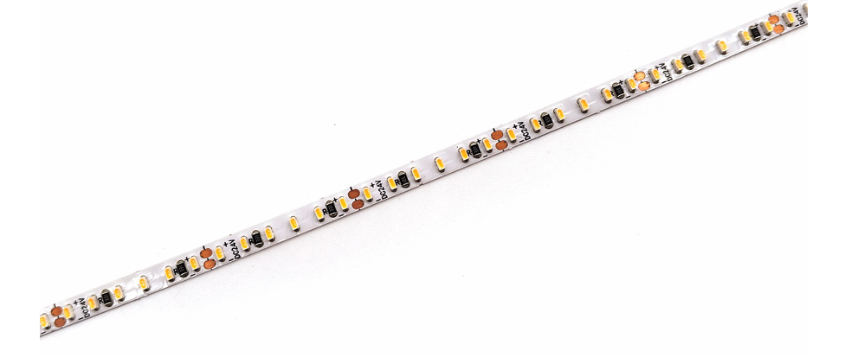

**Feature:**

* Super slim width with board width only 4mm
* High quality FPC, high thermal 3M adhesive
* Smaller size, higher density up to 300LEDs/m
* High cost performance and excellent in heat dissipation

**Product Specification:**

|  |  |
| --- | --- |
| Power | 11.5W/M 3.5W/ft |
| Voltage | DC24V |
| CRI | 90 |
| Led Qty | 240LEDs/M |
| Length/Reel | 5M 16.56ft |
| Working Temperature | -25~60°C |
| Storage Temperature | -30~80°C |
| Voltage Range | 23~25V dc |
| Reverse Voltage | 25V dc |

